Name:
Mrs. Reisma’s Week in Review
January , 2015

Reading:
Sight words: the, I, we, can, like, a, see, go, in, it, up, down, to, not, have, one, big, come, jump, is, away, play, help, make, blue, black, brown, green, orange, purple, pink, red, white, yellow
Practice reviewing these words at home

Letter/sound of week: We reviewed the letters and sounds this week.

Blending: We began adding a beginning letter to the word families _an and _at. We made a class list of each word family. Some of the words were not real words, we called them nonsense words.
Below, have your child fill in the beginning letter to make a word or nonsense word, and then have them blend it to say the word.
_at _an
Ex: mat can

__ at __ an

__ at __ an

__ at __an

Math –
And we reviewed identifying 3-D shapes and solving addition math sentences.
Science
This week we continued our study on keeping our bodies healthy. We focused on the 5 main food groups: fruits, grains, vegetables, protein, and dairy.
Have your child complete the plate below by drawing and coloring a food for each food group. If your child needs help labeling the foods please do so.
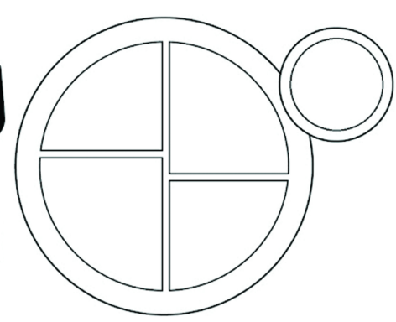
DAIRY
PROTEINS
VEGETABLES
GRAINS
FRUITS
Notes:
*Library books are due back Monday, January 30
*2 hour early out Wednesday, January 25
* We will be celebrating our 100th day party Monday, January 30th.
Have a Great Weekend,
Mrs. Reisma

HOME TO SCHOOL COMMUNICATION

Dear Parents,
Please let me know how you think your child did on this week’s review:
_____ 1. My child seemed to understand these skills.
_____ 2. My child needed some help with ________________________________________________.
_____ 3. My child needs more instruction on _____________________________________________.
Parent signature: __________________________________
Comments:

